*Discover the many remarkable aspects of Daisy State Park, by attending the scheduled interpretive activities that have been prepared with you and your family in mind. All programs are free and open to anyone who would like to attend, unless otherwise noted. If you are a child between 7 and 14, inquire at the Visitor Center or ask a Park Interpreter how to* ***become a State Park Explorer****!*



May 31st-June 3rd

|  |
| --- |
| **Thursday, May 31** |
| 2 p.m. - 2:30 p.m. | **Be an Explorer** Calling all explorers! If you love playing outside and visiting your state parks, come learn how you can be an official Arkansas State Park Explorer. Bring your family to this short program to help you earn your State Park Explorer badge! Meeting place: Amphitheater Admission: Free |
| 4 p.m. - 5 p.m.  **Friday, June 1**  2:30 p.m. - 3 p.m.  4 p.m. - 5 p.m. | **Making the Connection** Join Park Interpreter Liz on a 3/4-mile hike at Daisy State Park to make simple connections with nature. Be sure to wear appropriate footwear and bring water. Meeting place: Interpretive Center Admission: Free  **Discovering Arkansas's Snakes** Join park staff to discover the exciting world of snakes! We’ll explore the different types you might encounter here in Arkansas, as well as how to identify them. Visitors receive a free snake guidebook!  Meeting place: Visitor Center Admission: Free  **Nature Scavenger Hunt** This nature scavenger hunt is a great way to explore the outdoors and learn about nature. This activity will stimulate your creativity as you learn about the diversity of a wildlife habitat. Join Park Interpreter Liz for a guided hike in Daisy State Park to explore the wonders of nature. Don't forget sturdy shoes and insect repellent. Meeting place: Pavilion Admission: Free |
| **Saturday, June 2** |
| 10 a.m. - 12 p.m. | **Scenic Lake Tour** Lake Greeson is a beautiful place to make memories. Join us for a tour of Lake Greeson by boat to learn about the history and natural features of this lake. Don’t forget your camera! Seating is limited, so sign up at the visitor center by 5 p.m. on Friday. Meeting place: Area E Boat Launch Admission: $10 adults, $5 children ages 6-13, under 6 free |
| 2:30 p.m. - 3 p.m. | **Critter Crunch** Daisy State Park provides diverse habitat for all types of species large and small. Join us as we discover some of the smaller creatures and feed lunch to our co-interpreters, our speckled king snake and our turtles. Meeting place: Visitor Center Admission: Free |
| 4 p.m. - 5:30 p.m. | **Kayak Expedition**  Join Park Interpreter Liz for a tranquil kayak outing. This will be an easy kayak expedition, perfect for first time kayakers or those wanting a relaxing activity. Bring clothing and shoes that can get wet. Pre-registration by 1 p.m. Saturday May 19th is required at the visitor center. Meeting place: Area E Boat Launch Admission: $14 adults, $7 children ages 6-12, under 6 free with adult in tandem |
| **Sunday, June 3** |
| 10 a.m. - 12 p.m. | **Scenic Lake Tour** Lake Greeson is a beautiful place to make memories. Join us for a tour of Lake Greeson by boat to learn about the history and natural features of this lake. Don’t forget your camera! Seating is limited, so sign up at the visitor center by 5 p.m. on Friday. Meeting place: Area E Boat Launch Admission: $10 adults, $5 children ages 6-13, under 6 free |
| 2 p.m. - 2:30 p.m. | **Feel the Furs** You may see a variety of mammals in Daisy State Park, but what do you think their furs feel like? Join Park Interpreter Liz to discover some of these interesting animals and learn about their habitats. Meeting place: Interpretive Center Admission: Free |

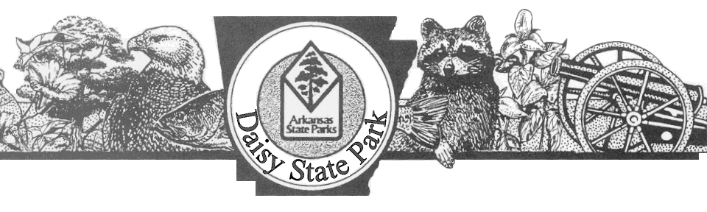

Tamara Lunsford, Park Superintendent Randy Hainen, Asst. Superintendent Liz Schneider, Park Interpreter

**Daisy State Park 103 East Park, Kirby, AR 71950 (870) 398-4487**