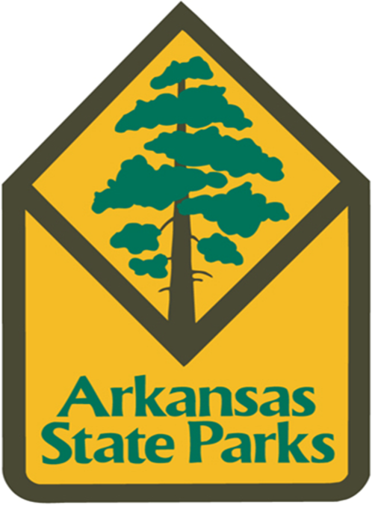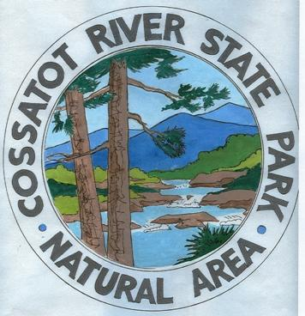
Cossatot River State Park-Natural Area
1980 Highway 278 W/Wickes, AR 71973 Phone: 870-385-2201
April, 07-08, 14-15, 21-22, 28-29, 2018

Saturday, April 07
9:15 a.m. – 10:15 a.m. Supermarket Sleuth (1 hour) Come along with Park Interpreter Flanary to test our detective skills as we discover where food really comes from. Don’t forget to bring your taste buds.
Meeting Place: Brushy Creek Picnic Area.
9:30 a.m. – 10:30 a.m. Migration Madness (1 hour) Spring has sprung and many animals are migrating back to Arkansas. Join Park Interpreter Carson to learn about these travelers and experience the journey that they face.
Meeting Place: Visitor Center’s Legacy Room.
2:00 p.m. – 3:00 p.m. Recon-Hike (1 hour) Join Park Interpreter Flanary on a special mission. Our objective is to search the surrounding area thoroughly, missing nothing. There have been signs of recent predator activity in this area, so it is important that we remain hidden and unseen. Wear only non-rustling clothing (like wool or cotton). Camouflage yourself. Wear quite walking shoes or boots. Plan for your clothes to get dirty and wear bug spray.
Meeting Place: Low Water Bridge below Visitor Center.
3:00 p.m. – 4:00 p.m. Look at Those Teeth! (1 hour) Looking at an animal’s teeth can tell you a lot about their life! Have you ever wondered why a beaver’s teeth look orange? Do snakes even have teeth!? Join Park Interpreter Carson to learn the answers to these questions and many more.
Meeting Place: Sandbar Picnic Area.
Sunday, April 08
9:30 a.m. – 10:30 a.m. Fire in the Forest (1 hour) Do you hear that? It’s the terrible sound of a crackling forest fire, coming straight towards us. There’s a fire in the forest, and every animal is running away, trying to escape without being caught and burned by the fire. Join Park Interpreter Flanary in this interactive challenging game as we discover what animals live here at Cossatot River State Park and how fire impacts wildlife.
Meeting Place: Brushy Creek Picnic Area.
2:00 p.m. – 3:00 p.m. Feed the Critters (1 hour) Ever wonder how or what snakes eat? Well, its dinner time and the critters are hungry! Come and watch their eating habits and learn about the animals here at Cossatot River State Park-Natural Area.
Meeting Place: Visitor Center.
3:30 p.m. – 4:30 p.m. Town Ball (1 hour) Join park interpreter(s) for a venture back in time as we learn to play an old fashioned friendly game of town ball.
Meeting Place: Yard Above Amphitheatre at Visitor Center.
Saturday, April 14 Pollinator Day 10:00 a.m. – 3:00 p.m.
10:00 a.m. – 10:10 a.m. Introduction, Orientation, Restroom
10:15 a.m. – 10:45 a.m. Cossatot’s Transformers (30 mins) This station reviews the life cycle of a butterfly. The participants “become a butterfly” themselves by going through the stages of metamorphosis in a relay game.
Meeting Place: Yard above Amphitheatre by Visitor Center.
10:50 a.m. – 11:20 a.m. Migration Madness Game (30 mins) Spring has sprung and many animals are migrating back to Arkansas. Join Park Interpreter Carson to learn about these travelers and experience the journey that they face.
Meeting Place: Yard above Amphitheatre by Visitor Center.
11:25 a.m. – 11:55 a.m. The Communication Station (30 mins) This station discusses how bees communicate through different dances. Students will learn how bees use the waggle dance; and, then learn to apply this knowledge in an interactive scavenger hunt.
Meeting Place: Butterfly Garden on Waterleaf Trail by Visitor Center.
12:00 p.m. – 1:00 p.m. Lunch, Restroom
1:05 a.m. – 1:35 p.m. Bee’s Knees (30 mins) This station is a craft area where they make a bee head band and hear a short story about Betzy the Bumblebee. This introduces students to the adaptations that make bees effective pollinators.
Meeting Place: Legacy Room B in Visitor Center.
1:40 p.m. – 2:10 p.m. The Power of Attraction (30 mins) This station allows students to have a hands-on learning experience to discover how pollination works. Students will use “pollinator gloves” and visit several flowers to see how the pollen is carried.
Meeting Place: Yard Above the Amphitheatre.

Mon

Sunday, March 31
Saturday, April 14 Pollinator Day 10:00 a.m. – 3:00 p.m. Continued
2:15 p.m. – 2:45 p.m. The Garden Buzz (30 mins) This station will teach participants what they can do at home to help the pollinators in their back yard. Participants will create “seed bombs” to put in their yard.
Meeting Place: Legacy Room A in Visitor Center.

Sunday, April 15
9:30 a.m. – 10:30 a.m. Picture Perfect! (1 hour) It’s spring time and the park is ready for its close up! Join Park Interpreter Carson on a small hike on the River Corridor Trail so we can take some photos with our cameras or eyes.
Meeting Place: Cossatot Falls Parking Lot.
2:00 p.m. – 3:00 p.m. Feed the Critters (1 hour) Ever wonder how or what snakes eat? Well, its dinner time and the critters are hungry! Come and watch their eating habits and learn about the animals here at Cossatot River State Park-Natural Area.
Meeting Place: Visitor Center.
3:30 p.m. – 4:30 p.m. Town Ball (1 hour) Join park interpreter(s) for a venture back in time as we learn to play an old fashioned friendly game of town ball.
Meeting Place: Visitor Center’s Amphitheatre.
Saturday, April 21
9:00 a.m. – 10:30 a.m. Wildflower Walk (1 hour 30 mins.) Come to the Cossatot River State Park and enjoy the beauty of spring wildflowers with Park Interpreter Carson. Many of these wildflowers are unique to the area, occurring only in the Ouachita Mountains.
Meeting Place: Harris Creek Trailhead.
1:45 p.m. – 2:30 p.m. The Garden Buzz (45 mins) This station will teach participants what they can do at home to help the pollinators in their back yard. Students will create “seed bombs” to put in their yard.
Meeting Place: Legacy Room in Visitor Center.
3:00 p.m. – 3:30 p.m. Plant to Pantry (30 mins.) The Grist Mills used in communities surrounding Cossatot River State Park- Natural Area provided food to Arkansans by taking grains from the plant to the pantry. Visit with Park Interpreter Carson to see a grist mill and learn how it operates.
Meeting Place: Visitor Center.
Sunday, April 22
9:00 a.m. – 10:30 a.m. Birds on a Stick (1 hour) There are two kinds of birders. Ever wondered which kind you are? Meet Park Interpreter Flanary as we discover which kind of birder you are. If you have a drab-colored blanket or sheet, please bring one. Bring a bottle of water, and wear your bug spray.
Meeting Place: Low Water Bridge below Visitor Center.
2:00 p.m. – 3:00 p.m. Feed the Critters (1 hour) Ever wonder how or what snakes eat? Well, its dinner time and the critters are hungry! Come and watch their eating habits and learn about the animals here at Cossatot River State Park-Natural Area.
Meeting Place: Visitor Center.
3:30 p.m. – 4:30 p.m. Town Ball (1 hour) Join park interpreter(s) for a venture back in time as we learn to play an old fashioned friendly game of town ball.
Meeting Place: Visitor Center’s Amphitheatre.
Saturday, April 28
9:00 a.m. – 9:45 a.m. Do You Speak Frog? (45 mins) Many insects “sing” at night, but did you know that most Cossatot’s nighttime noise comes from frogs? Can you communicate with them? Hop on over to find out more about our local frogs and learn fun ways to identify their musical sounds. You’ll even have a chance to join the “Frog Chorus!”
Meeting Place: Sandbar Picnic Area.
10:45 a.m. – 11:45 a.m. Otter Steals Fish (1 hour) Have you ever seen a Great Blue Heron catch a fish? Meet Park Interpreter Flanary in this flurry of fun, as we discover a few basic Cossatot River State Park animal behaviors and predicaments.
Meeting Place: Yard Above the Amphitheatre.
2:00 p.m. – 3:00 p.m. Cossatot Craft Corner (1 hour) It is the last Saturday of the month; and that means it is time for Cossatot Craft Corner. Do you enjoy being creative? Would you like to begin earning an explorer badge? Join Park Interpreter Carson to use your creativity, have fun, and discover something special that can be found in the park.
Meeting Place: Visitor Center’s Legacy Room.
3:30 p.m. – 4:30 p.m. Regurgitation Situation (1 hour) How can you tell what an owl ate for dinner? Join Park Interpreter Flanary and hear it straight from an owls mouth as to what they had for dinner.
Meeting Place: Sandbar Picnic Area.
Sunday, April 29
9:00 a.m. – 10:30 a.m. Journey Stick Hike (1 hour 30 mins) In many countries people have developed the idea of creating a journey stick to help them tell the story of their journey to others. Meet Park Interpreter Carson to enjoy a hike and create a journey stick to remember your adventure.
Meeting Place: Cossatot Falls Parking Lot.
2:00 p.m. – 3:00 p.m. Feed the Critters (1 hour) Ever wonder how or what snakes eat? Well, its dinner time and the critters are hungry! Come and watch their eating habits and learn about the animals here at Cossatot River State Park-Natural Area.
Meeting Place: Visitor Center.
3:30 p.m. – 4:30 p.m. Town Ball (1 hour) Join park interpreter(s) for a venture back in time as we learn to play an old fashioned friendly game of town ball.
Meeting Place: Visitor Center’s Amphitheatre.

